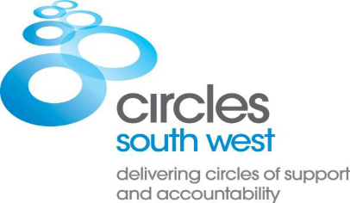**CORE MEMBER Eligibility and Suitability**

**ADAPTED CIRCLES FOR CORE MEMBERS WITH INTELLECTUAL DISABILITY**

**All referrals meeting the stated criteria will be considered, with priority given to those assessed as high or very high risk of serious harm**

**Please discuss suitability with Circles South West before completing the referral form**

**Eligibility**

|  |  |
| --- | --- |
| HISTORY OF HARMFUL SEXUAL BEHAVIOUR | A history of harmful sexual behaviour (convicted or un-convicted) against adult or child (includes non-contact offences). Historic sexual offences/behaviour may also be considered if relevant risk and need criteria met. |
| INTELLECTUAL DISABILITY | Those with a diagnosis of mild or borderline learning disability; suitability of the service to be discussed on an individual basis |
| RISK CLASSIFICATION | If relevant - OASys or ARMIDILO-S: Medium, high, or very high risk of serious harm  OSP/DC/IIC: all likelihood of sexual reoffending classifications will be considered |
| GENDER | Any |
| AGE | 18 years or over |
| ATTITUDES & BELIEFS | Acknowledges that they have committed harmful sexual behaviour and have a desire to avoid it in future. |
| STATUS | Statutory supervision by NHS, Social Care, Probation, and/or Police. |

**Suitability**

|  |  |
| --- | --- |
| UNDERSTANDING & MOTIVATION TO STAY SAFE | To have completed some work to understand why they offended, to have a realistic keep safe / risk management plan, and to understand that plan |
| LEVEL OF ENGAGEMENT | Prepared to engage with a Circle on a voluntary basis, to be able to travel to weekly meetings independently and to have an interest in group mentoring |
| SITUATION | Living in or about to be released into the community |
| AREAS OF NEED CAN IN | * Sexual preoccupation * Low self esteem * Lack of appropriate intimate relationships * Lack of pro social network * Emotional loneliness * Social isolation * Impulsivity * Poor problem solving * Lack of employment/ hobbies |